Subhead:
March 4, 2013
Subhead:
Dr. Pablo Gomez III Performs First Ever Pediatric Robotic Surgery in Latin America
Include headshot of Dr. Gomez
link underlined text to corporate site bio : https://www.fhmedicalgroup.com/physicians/pablo-gomez-md
Leading a team from Florida Hospital, Dr. Pablo Gomez III, specialist at Florida Center for Pediatric Urology and Medical Director at Florida Hospital for Children, recently performed the first ever pediatric robotic surgery in Latin America. Dr. Gomez, a third generation physician from Columbia who attended Harvard Medical School, performed the procedure on a child with a congenital defect at Clinica Marly in Bogata. In addition to the surgery, Dr. Gomez and leaders from Florida Hospital visited with key Columbian health officials to discuss potential shared opportunities in health care.

Subhead:
Physicians Spotlight
Copy:
FHMG expands our reach with the addition of Advanced Surgical Care Specialists and Mid-Florida Family Medicine. Please welcome our newest physicians as FHMG continues to grow and broaden its medical presence in Central Florida.
Header:
Advanced Surgical Care Specialists
The elite and established surgical team at Advanced Surgical Care Specialists, formerly General and Vascular Surgical Associates, PA, joined FHMG in February 2013. Located in Lake Mary, the practice offers the latest in surgical techniques, including open, endoscopic, and minimally-invasive laparoscopic and robotic procedures. The surgery center is led by Nicole BaiRossi, MD, FACS, William L. Huether, III, MD, FACS and John W. Robertson, MD, FACS. All three surgeons are board certified and trained in robotic and single-incision surgery (robotic single port surgery), to provide patients with expert, compassionate care for a broad range of surgical needs.

Subhead:
Board-Certified, Fellowship-Trained Surgical Team
[Include photos]
Nicole BaiRossi, MD, FACS, Board-Certified General Surgeon
William L Huether, III, MD, FACS, Board-Certified General Surgeon
John W. Robertson, MD, FACS, Board-Certified General Surgeon

Header:
Leyberth Rosendo, MD
Mid-Florida Family Medicine

Dr. Rosendo is board certified in family medicine and has been practicing primary care medicine since 1995, with nearly 15 years in Central Florida. Since opening his Apopka-based practice in 1999, Dr. Rosendo has provided comprehensive family medical care to patients five years and older, including occupational medicine and urgent care. In addition to special interests in managing chronic illness and sleep medicine, he can perform many lab tests, screenings, immunizations and procedures right in his office, such as EKG and Holter monitoring, digital X-rays, ultrasounds, urinalysis, spirometry and much more. The practice provides appointments as early as 6:30 am on Wednesday and Friday. Dr. Rosendo is fluent in English and Spanish. Serving patients age 5 and older. 407.889.8008

Subhead:
Customer Focus Corner
Copy:
It’s here! The ONE training program for employees of FHMG to improve the customer/patient experience. Join us as we embark on ONE journey to deliver ONE amazing experience to our customers and patients to reach the ONE destination of preeminence for FHMG. This week begins the ONE training program. Speak with your Office Manager to ensure you have been registered to attend in your region.

[Make images smaller]

Subhead:
Backpacks for Kids…Is Back!
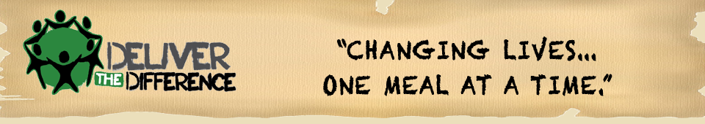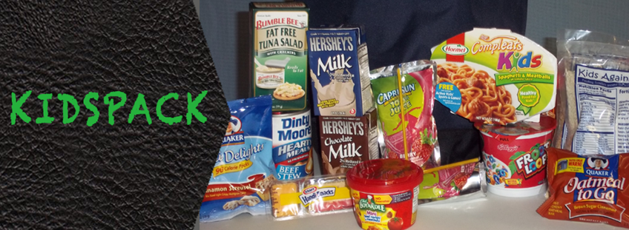
Copy:
The Weekend Backpack Program will help support hundreds of children that go malnourished every day. In Lake County alone, there are over 3,500 homeless school children! We invite you to join us in making a difference in these children’s and their families’ lives.
WHO: FHMG employees have the ability to change lives!
WHAT: Provide items from the KIDSPACK list.
WHEN: Starting now through March 31, 2013
WHERE: Fill boxes with items from the KIDSPACK list and send them to Stephanie Whitley in FHMG administration.
The KIDSPACK Program provides backpacks of food to needy children in schools. Each backpack contains: 2 breakfasts, 2 lunches, 2 snacks, 2 fruits, 2 milk boxes, and 2 juice boxes.

Subhead:
Items Needed for the Kidspack Program
- Single Serve Cereal
- Pop Tarts
- Cereal Bars
- Macaroni and Cheese
- Single serve Spaghetti O’s, Beef-a-Roni, Beef Stew, etc.
- Single serve Fruits
- Single pack Raisins
- Single serve shelf stable Milk
- Single serve Chocolate Milk
- Single serve Snacks
- Single serve Juice Boxes

Every Friday, children receive a backpack with food for the weekend because of your generosity.
Learn more at www.deliverthedifference.org

[Boilerplate copy]
Like FHMG on Facebook, follow us on Twitter, watch us on YouTube and bookmark our website.

